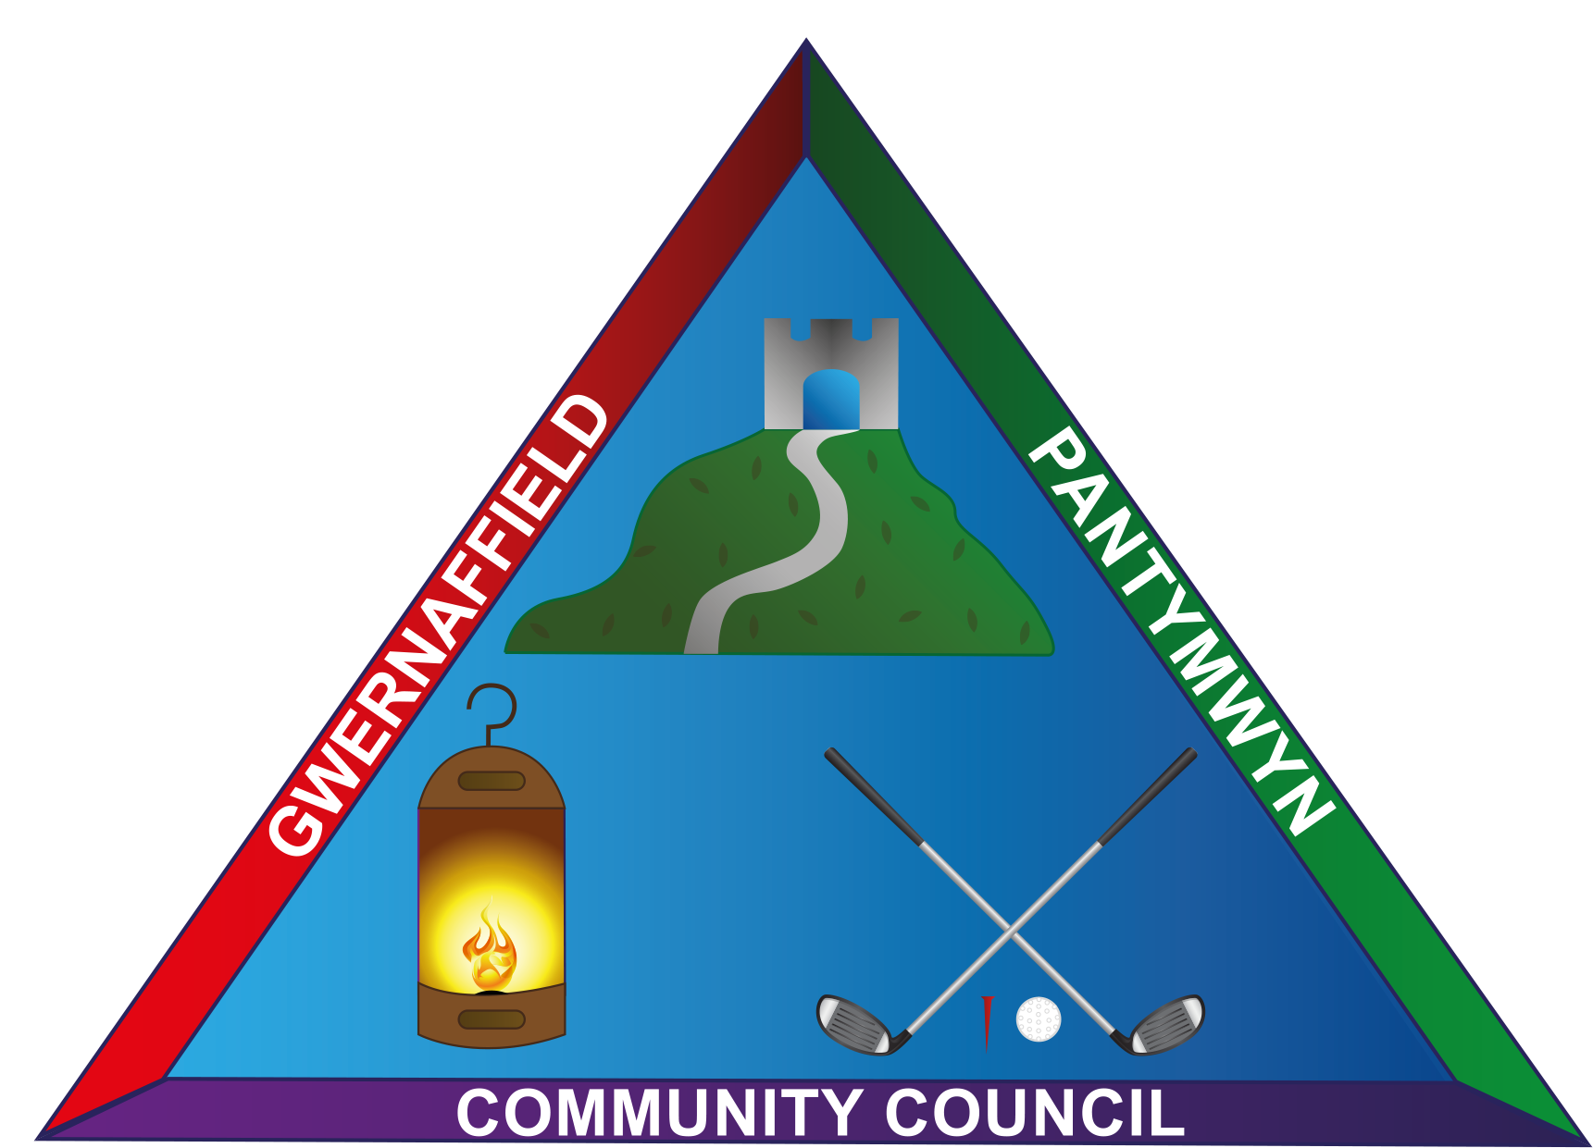
Gwernaffield and Pantymwyn
Community Council
Newsletter –April 2018
Issue No 12

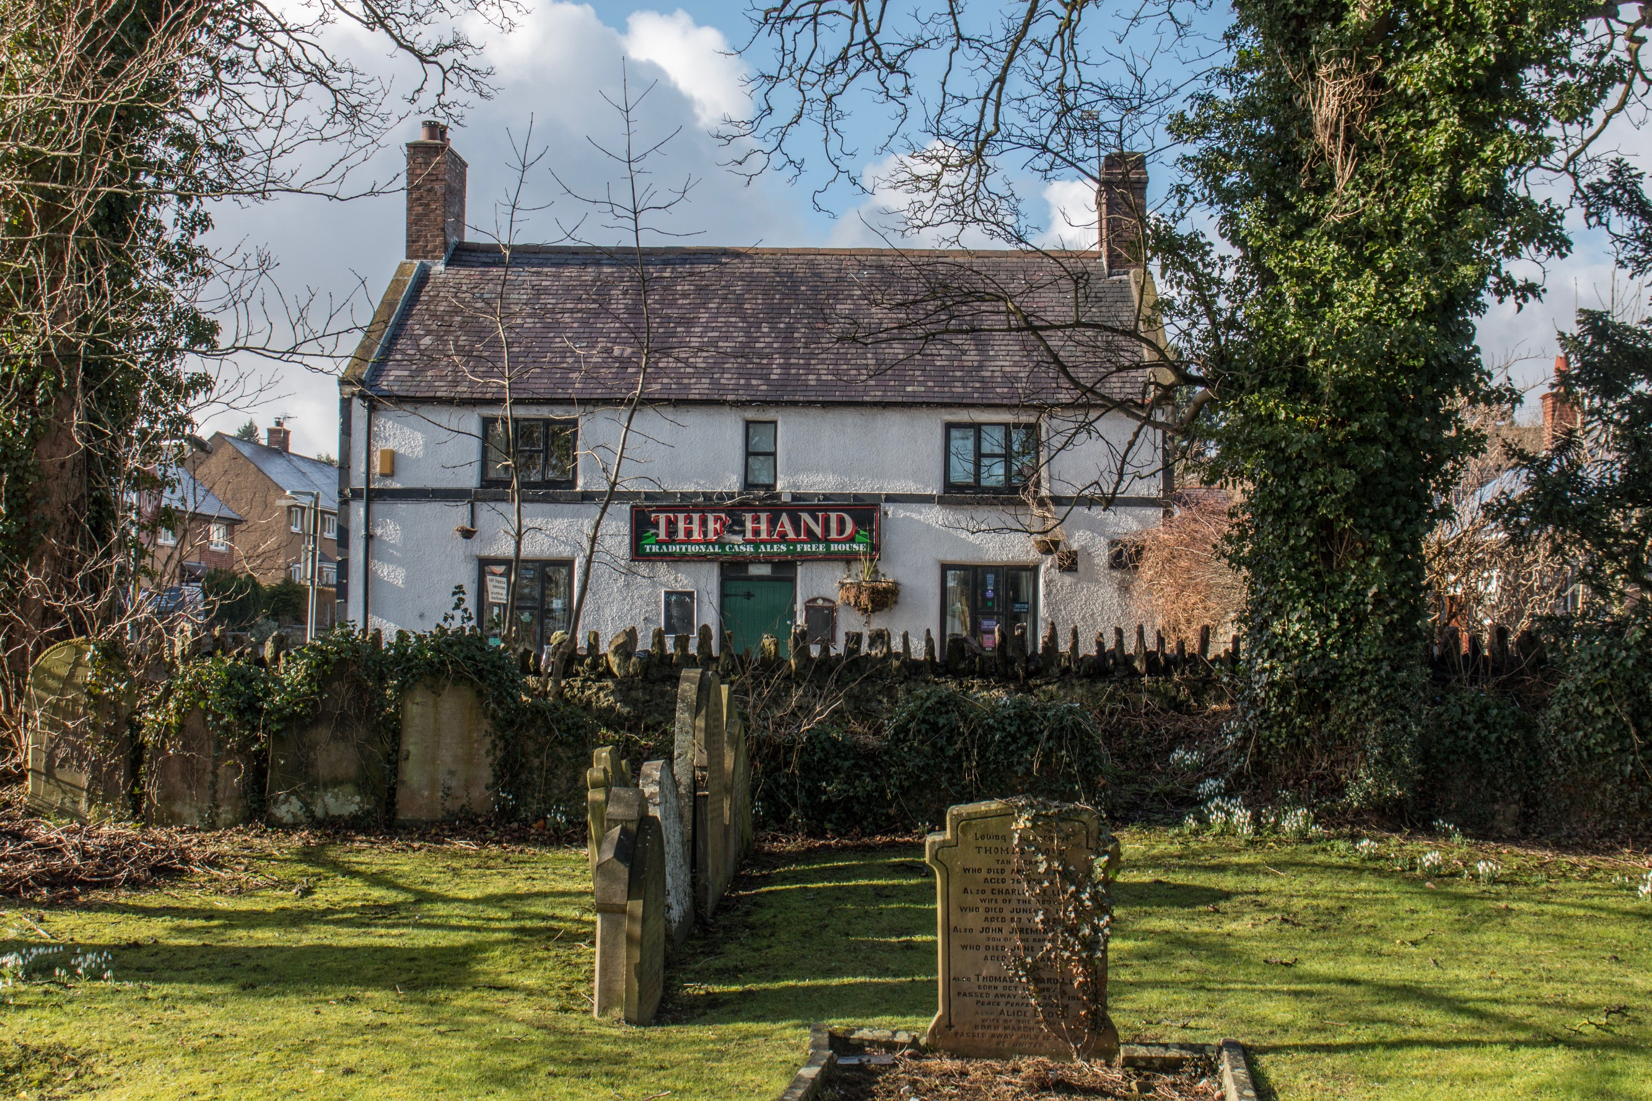

Photo sent in by Dave Jowitt

Have you a photo of your Group,Club, or the Locality then please contact: Email: lynnepritchard51@gmail.com

Community Council News

- Complaints have been received regarding the state of the road from the quarry.Cllr. Tattum had attended the quarterly liaison meeting where this was reported. Cllr Johnson had been in touch with the Quarry Manager, Mr Jason Parry who advised the quarry has had a large order for material from the aggregates division received on site resulting in a greater amount of loading and movement. The quarry has increased the frequency of the road sweeper.

- Cllr. Johnson reported on a successful “Big Dig” in Gwernaffield Park/Playing fields, over 30 people attended from the villages, including the scouts and residents who planted plants, hedges also in the conservation garden. Cllr. Johnson thanked the clerk for her attendance and hoped more community councillors would attend future events. Trees/shrubs will now be received twice yearly from the woodland trust.

- The clerk reported to members about the pre-deposit proposals public consultation (preferred strategy) Flintshire Local Development Plan 2015 – 2030. This is available on the Councils website www.flintshire.gov.uk/idp
Councillors asked the clerk to comment that Gwernaffield and Pantymwyn Community Council do not have the infrastructure to deal with significant housing development.

- The clerk reported on an update on Street light renewal from County. Mr Darell Jones, Street lighting manager informed members that all sox owned lights by Flintshire County Council will be being replaced in the next 6 months.

- The clerk reported she had contacted Mr Lightfoot again to request a chase on white lines on Cilcain Road and the junction in Y Waen also cutting back on the trees in Y Waen. Mr Lightfoot will look into the progress of these work requests. The trees in question are owned by leisure services and June Morris would be responsible.

- The clerk had also reported litter/waste being discarded on Cefn Bychan Road from the recycling vehicles, there was a lot of this on the road Mr Lightfoot will speak to the relevant team.
- The clerk reported Mr Lightfoot was in the process of submitting a funding bid to Flintshire County Councils road safety unit to improve the footpath from Factory Pool Lane to Fford Y Bryn down into Mold. Mr Lightfoot will inform the community council of any future developments.

- Councillors expressed some concern about a lack of gritting particularly on Pantybuarth Road and Pen Y Fron Road. Although these routes may be defined by Flintshire County Council as Priority 2 routes when it comes to gritting, concern was expressed due to the gradients they are at which makes them more dangerous. Ysgol Y Waun also struggled during the snow fall with the teaching staff having to do a lot of snow removal and make safe the surrounding area. . Mr Steve Jones, Manager Street Scene and Councillor Carolyn Thomas, Cabinet member for Streetscene and Countryside said in response to the community councils letter of concern regarding winter maintenance for rural villages.
Flintshire County Councils winter maintenance policy is in line with national guidelines and is reviewed every two years. This is subject to full scrutiny and cabinet approval. Flintshire County Council has to keep roads clear of ice and snow as much as reasonably practical.
Mr Jones showed a map which demonstrated where the gritting routes are and how this has changed in recent years. Changes were due to inconsistency in where Flintshire County Council used to grit compared to other rural areas and this had to be rectified. He confirmed some agricultural routes had been removed.
Cllr. Armstrong suggested taking the concerns about gritting/road
safety matters to the next Town and County Forum as it is likely other
community councils are experiencing similar problems
Cllr. Armstrong agreed to attend the next meeting.
On a positive note, Cllr. Johnson said the community responded well
and helped one another during the bad weather conditions.

- Cllr. Elcock reported a “black spot” in terms of street lighting on Cefn Bychan Road. Cllr. Bolton said once the lighting renewal project had finished, it was previously agreed to look back at any areas. Pantymwyn Councillors agreed to meet and look at this area one evening and feedback.

- Councillors agreed to review the hire of hall for the youth club during 2018/2019. There is still no advance notice of when it is going to be cancelled. Cllr. Pritchard is at present getting no response from Mr Holt, Flintshire County Councils Youth Service.

- Match Funding Scheme – funding response from Aura to expression of interest for Gwernaffield Playing Fields. Due to the number of expressions of interest received from Town and Community Councils, they have exceeded the level of funding available from the Council. All expressions of interest received have been reduced by 50% in value. Therefore the original expression of interest from Friends of Gwernaffield Playing Fields and the Community Council was £5,000. Flintshire County Council will now offer £2,500.
Cllr. Lynne Pritchard and others from Friends of Gwernaffield
Playing Fields will be meeting with Mr Richard Roberts, Aura. Due
to the reduction in money, Mr Roberts has suggested a smaller child
friendly play area.
Mr Richard Roberts had also advised of a sum of £2,850 earmarked
for the play area, to be used to replace the fence to the right
hand side of the gate entrance .
New toddler play equipment is to be put in the Playing Field in
the spring.

- The clerk had worked with the Chair and Vice Chairman on the proposed 2018/2019 budget which had been circulated in advance of the Feb meeting. In year, savings had continued to be made in particular on street lighting electricity and maintainence which would continue and have been reflected in the proposed budget. The budget was considered and discussed – A precept for £32,500 (0.99% increase) was agreed.

- Community events - Cllr. Armstrong is to take over Community Council events and with a sub group will look at events throughout the year. A proposal by Cllr. Pritchard, seconded by Cllr Armstrong to increase the community events budget from £800 - £1000. 7 votes for, 1 against, 2 abstain.
The clerk provided Cllr. Armstrong with guidance from the Standing
Orders on Sub Committees as she will be establishing a group to co-
ordinate local events in the Community. Cllr. Pritchard has
furnished Cllr. Armstrong with a list of those events which she had
previously done over the past few years.

- Cllr. Lynne Vaughan resigned as Councillor for personal reasons. The clerk placed a vacancy notice on the notice boards and website.

- Review of Community Councillors attendance at monthly meetings:
Cllr. Pritchard reported briefly on the importance of regular
Councillor attendance and commented that only a third of councillor
has attended all meetings since May 2017.
A register will be published at the end of each financial year showing
each Councillors attendance.

- Cllr Hughes attended a meeting of Penyfford Community Planning Group on 31 January 2018. He explained a number of Councils are under pressure for big housing developments including Penyffordd, Llay, Rossett, Hope and Wrexham. Planning objections and enquiries have been made by community councils and there was a general feeling that the community councils input is not taken seriously. Therefore, if the community councils grouped together would this have more influence. it was agreed it would be beneficial if Gwernaffield and Pantymwyn Community Council had a representative on this planning group. Cllr Hughes to act as representative on Penyffordd Planning Group.
Planning matters and Planning Decisions
- Reference 057760. Mount Pleasant, Cilcain Road, Pantymwyn. Listed building application for internal alterations and erection of porch over main door
Resolved: No comments received from Councillors.
- Planning reference 057710: Cornerways, Cefn Bychan Road Pantymwyn, Erection of replacement dwelling - Decision Approved.
- Planning reference 057038: The Barracks, Pantybuart
Planning Refused
- Mold Golf Club, Cilcain Road, Pantymwyn, Mold CH7 5EH. Decision: Refused. An appeal has been made to the planning inspectorate.
FCC – Domestic EnergyTeam
Warm Home Fund – will fund measures in properties that are non gas-that do not currently use mains gas as the primary source of heating source via a central heating system and/or a household living in premises which are not connected by a pipe to a distribution main.
Do ot have a central heating system installed . A central heating system is defined as a heat generator providing heat to several rooms via a heat distribution system. You must follow one or more of the following criteria:
- Within the 25 % of the most deprived areas
- Eligible for support under nest
- In fuel poverty – if the household spends more than 10 % of disposable income on all fuel use.
For more info: Joanna Seymour - HealthyHomesHP@Flintshire.gov.uk
Shelly Webster – shelly.webber@flintshire.gov.uk 01352 703425 / 703440

FRIENDS OF GWERNAFFIELD PLAYING FIELD
ARE TO HOST A

ON SATURDAY the 14th July 2018
Church Hall Field
12.30 – 5 pm

Coconut Shy

Bouncy Castle

Fancy Dress Theme for both Children and Adults
any Country - National Costume

Any local group who would like a stall please contact: Lynne on
01352 740972/lynnepritchard51@gmail.com

History in the Making!
Pantymwyn and Gwernaffield Photo Archive 2018.

In an exciting project for 2018 the Pantymwyn and Gwernaffield Photo group will be seeking to compile a photo archive of a year in the life of the two villages and environs for future generations to use and enjoy. Members of the group will be busy compiling a library of pictures, highlighting the events, life and beauty of the village throughout the year, including its people & diversity, community & events, landscapes & architecture, industry & leisure, music & arts and flora & fauna.
We are hoping to do an exhibition of the results in early 2019, and the Flintshire County Archives in Hawarden has already agreed to include the output of the project.
We would love the support of the whole community on this, not just personal photo contributions, but also feel free to invite us along to your events so we can provide a full and representative cross section of images for the archive.

For contributions, further information and questions, as well as suggestions for inclusions (and also if you specifically want not to be included) please contact:-
steven.partner@googlemail.com or dave_jowitt@yahoo.co.uk .

................................................................................................................................

Every 3rd Sunday in the month
4pm – 6pm
Gwernaffield Church Hall

Next events
15st April 2018
20th May 2018
24th June 2018

Gwernaffield Church Hall
At some of the bookings below refreshments are available.

Weekly Events | AM | PM
Monday |  | Youth Group 6.30-9.30
Tuesday | Morning Coffee  10 – 11am | WI second Tuesday of the month 7.30 – 9.30  Mothers Union Last Tuesday  7 – 9pm
Wednesday | Bowls  10 - 12 | Table Tennis 2 – 4  Band 6.30 - 9
Thursday |  | Thursday Club 2 – 4  Cubs 6.30 – 8.30
Friday |  | Table Tennis 2 – 4  Beavers 5.30 – 6.30  Scouts 7 - 9
Saturday | Open all day for | Special Events and  is available to hire  Call Gwyneth 0n 740488
Sunday | Sunday Praise Service  4th Sunday  9.30 – 10.30
A small Lottery grant has recently been secured for improvements to the hall. This has enabled a smart new screen of cupboards to be built providing extra storage space for all the hall users. A new PA system with hearing loop is being installed and we hope to install some mood lighting to provide more atmosphere widening the appeal of the hall for a variety of events.
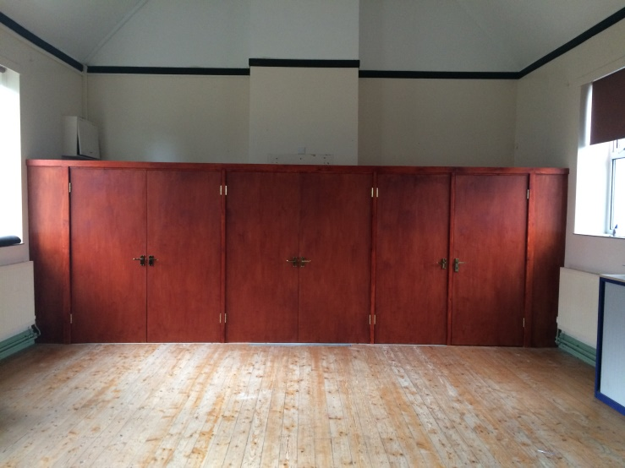
‘ This has been funded jointly by The Lottery, Cilcain Young Farmers and the Gwernaffield Church Hall Association’
‘ DEFIBRILATOR TRAINING WILL BE HELD IN THE CHURCH HALL AT 5 pm ON THURSDAY 12TH APRIL –come and find out how to use it and potentially save a life’.
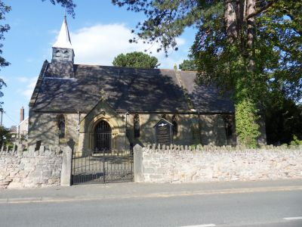
Holy Trinity Church Gwernaffield

“ Events ”

.
Saturday 14th April - 10.00am - 12.00noon.
Coffee morning with Bric-a-Brac Stall and Home-made Cake Stall.
Join us for a cuppa and a chat.

Saturday 28th April - 7.00pm.
Soup and Scrabble Evening
Entry: £3.00.(this includes Soup and tea/coffee.)

Saturday 9th June - 7.00pm
Back by Public demand - 'The James Lambert Singers"..
Tickets:- £8.00 (including refreshments)

GWERNAFFIELD CHURCHYARD & NEW CEMETERY

We would respectfully like to remind people, who have loved ones buried in the Churchyard & New Cemetery, that the recent erection of kerbs adjoining headstones, artificial flowers & ornaments are not allowed under Church in Wales Churchyard regulations:

Item 17: Save for silk flowers & Remembrance Day poppies, no artificial wreaths or flowers, shrubs, permanent flower vases or containers, chippings, gravel paving stones or kerbs shall be placed on or around any grave.

We wish to continue to maintain the grounds tidily for the benefit of all but increasing numbers of kerbs have appeared. This is making it very difficult for the ground maintenance team & also more costly -£7,600 in 2017.
Recent kerbs need to be removed by May 31st 2018. If they remain, they will be dismantled.
Please contact Rev’d Daniel Stroud with any queries. Tel: 01352 810694.

Gwernaffield Church Committee
CONGRATULATIONS TO ANN MATHER- Volunteer of the Year Award

Ann Mather, from Pantymwyn has won ‘The Marsh Volunteer of the Year Award’ for her sterling charity work at Barnardo’s. She was also presented with a beautiful Rose Bowl for her dedicated service with the charity. Ann first started as a volunteer 40 years ago when she had a Barnardo’s Box (Little Cottage) to fundraise for the charity & over the years has strengthened her contribution with the Box holder group in Mold. Ann also enjoys volunteering at the Barnardo’s shop in Mold. Closer to home, Ann has been very active on the Pantymwyn Village Hall Committee for many years and is currently the President.
Well done Ann! If anyone is interested in having a little cottage box to collect pennies for Barnardo’s please contact Ann personally

PANTYMWYN VILLAGE HALL MANAGEMENT COMMITTEE

WISH TO THANK YOU FOR YOUR IDEAS ABOUT HOW TO CELEBRATE 70 YEARS IN THE COMMUNITY.
By popular demand we will be hosting a
SPECIAL 1940’s afternoon of Music & Entertainment on SATURDAY 5th MAY 2-4pm.



Tea & cakes galore!
Please put this afternoon in your diary. The hall first came to the village in 1948 so we are hoping the event will take us back in time. Feel free to bring your neighbours. Dress up 1940’s style if you wish. All ages welcome!
BIG Raffle to be drawn at 3:45pm.
‘Celebrating 70 Years in the Community’
TICKETS £2
1st Prize £100, 2nd Prize £50
with many other prizes donated by local businesses.
Raffle tickets on sale from Committee members
ADVANCE NOTICE
HELFA GELF is coming to Pantymwyn Village Hall again this year
Fri 7, Sat 9 & Sun 10th Sept
We are looking forward to a spectacular display of work from Marlene Clarke (our local artist in residence) & her daughter Kirsten, who is designing handmade cards

Pantymwyn WI Tuesdays at the Village Hall
New members always welcome!

April 3rd AONB Pontycyllte Aquaduct
May 8th Resolutions
June 5th Guest Afternoon- mystery speaker
July 3rd Rhiannon Evans- Joyce’s War

PANTYMWYN VILLAGE HALL AGM

JOIN US on Thursday May 17th 7:30pm
Every year we plan ahead for the following year. This is your chance to shape events at the village hall.
New ideas & people are always welcome.

CHARITY TEA & CAKES
IN AID OF NIGHTINGALE HOUSE WREXHAM
........................................................................................................................
To The Community of Gwernaffield and Pantymwyn

We would like to INVITE YOU ALL to help and support us by coming along to Pantymwyn Village Hall on Saturday 16th June from 2 to 4 pm.

PLEASE COME - BUY A CUP OF TEA - COFFEE

AND A SLICE OF CAKE

IN AID OF OUR LOCAL HOSPICE IN WREXHAM.

Any offers of a cake, raffle prize or help

then please Contact either :

Teddy Hattersley - 740373 Or Jan Hodgson - 740597

If you would like to organise & run a stall in aid of the hospice, then give us a call.
Thank you - Jan & Teddy

Saturday 12th May 2018
1.30 – 4.00pm.
Your local Gwernaffield and Pantymwyn Community Council is organising a Spring Clean in our villages
It would be great if you could get involved and lend a hand – even for an hour. Let’s get our villages looking as clean and green as we can.
It might just be you and your family and friends, or you may know an organisation that can help………

Equipment and guidance will be provided at both Village Halls, with refreshments to finish!
Gwernaffield and Pantymwyn
Spring Clean
INCLUDEPICTURE "http://images-partners.google.com/images?q=tbn:ANd9GcSST_Lb67OENDPkP3wIHTNEEfLlYERpoo_8UEiA7KLlk1rDKm41p9z7jQ:http://drdeclutterblog.com/wp-content/uploads/2013/02/org-pick-up-litter-300x300.jpg" \* MERGEFORMATINET
Gwernaffield and Pantymwyn Spring Clean
INCLUDEPICTURE "http://images-partners.google.com/images?q=tbn:ANd9GcSST_Lb67OENDPkP3wIHTNEEfLlYERpoo_8UEiA7KLlk1rDKm41p9z7jQ:http://drdeclutterblog.com/wp-content/uploads/2013/02/org-pick-up-litter-300x300.jpg" \* MERGEFORMATINET
Contact…
Kate Johnson (0789 0646 870)
the_pixiecat@hotmail.co.uk
Karen Armstrong (077 3333 6518)
karmstrong7@hotmail.com

................................................................................................................................
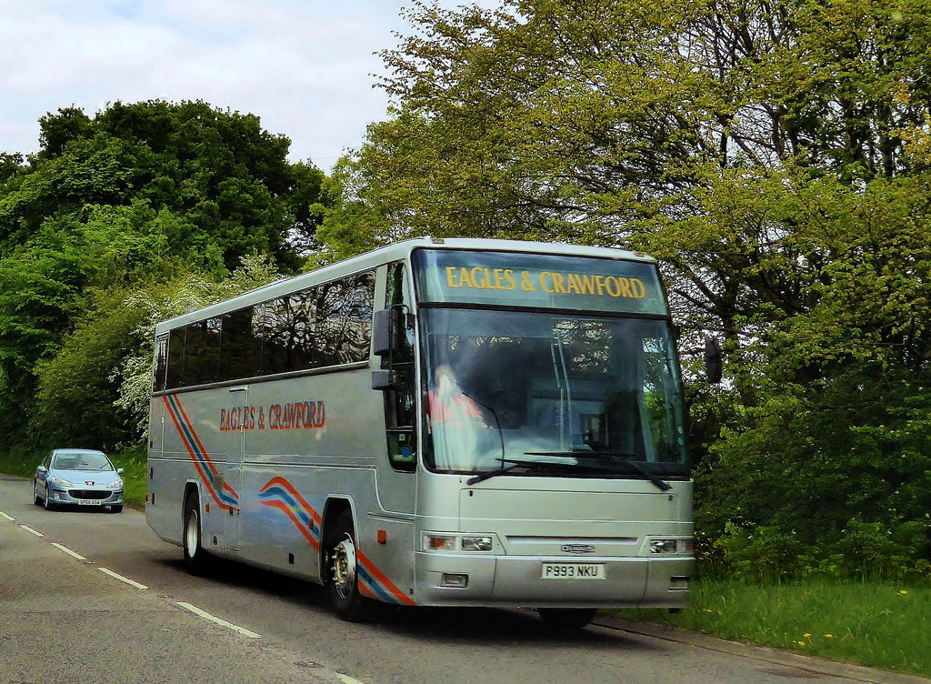
Thursday Club
Thursday club will be running Coach trips again this year, the trips are also open to any non members of the club. So if you fancy a day out then please call SheilaSmith on: 01352 740027 to book a seat
and get prices.

14th May Nantwich
14th August Beaumaris Angelsey
22nd November Xmas shopping trip combining Christmas Lunch at
“The Queens Hotel”

