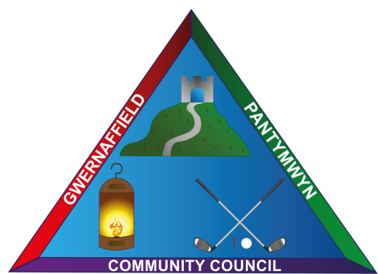

Dear Councillors / Annwyl Gynghorwyr
You are hereby summoned to a virtual zoom meeting of Gwernaffield and Pantymwyn Community Council at 7.00pm on 2 June 2021.
The meeting will consider the agenda items below.

Mrs Kay Roberts
Clerk
Agenda 2 June 2021 / 2 Mehefin 2021

1.(A) Attendance (B) Apologies
2. Declaration of interests in relation to the listed agenda items.
3. To consider any Streetscene Matters
4. To receive an update on the community councillor vacancy
5. To approve the June accounts for payment
5a. To receive the Annual Bank Reconciliation for 2021/2022.
5b. To receive and approve the report and Annual Accounting Statement
for 2019/2020 from JDH Business Service Ltd who have conducted the internal audit.
6. To agree the purchase of a leavers gift for Year 6 Ysgol Y Waun School Leavers 2021/2022.
7. To receive a verbal update from the Community Events Committee
8. To receive a verbal update from the Community Road Safety Committee
9. Planning Applications (A) Planning Decisions (B)
(A) Planning Application Ref: 062442 Pantybuarth Cottage, Pantybuarth, Gwernaffield, CH7 5ER
Proposal: Conversion of existing dog kennels to an annexe with two bedrooms, home office and living space.
(B) Planning Application Ref: 062489 Norlands, Pantymwyn – Approved.
10. To receive items for the last meeting on Wednesday, 7 July 2021 before the August recess period.

