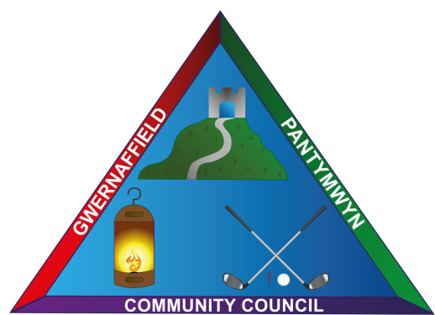

Dear Councillor
You are hereby summoned to a meeting of Gwernaffield and Pantymwyn Community Council, Community Centre, Ysgol Y Waun at 7.00pm on 12 June 2019. The meeting will consider the agenda items below.
Yours sincerely

Mrs K L Roberts
Clerk
___________________________________________________________________
AGENDA Wednesday 12 June 2019
Members of the public are welcome to attend
- To record (A) attendance (B) apologies.

- To record any declarations of interest from members.

- To approve the minutes of the last meeting on 22 May 2019

- To consider matters arising from the minutes

- Chairman’s Communications – Community Council Newsletter and feedback from the Chairman’s visit to Cefn Mawr Quarry.

- To discuss and consider Streetscene Matters
6a. Councillor Justin Roberts – information on a portable traffic speed monitor - Cllr. Justin Roberts.

- To receive an update from Flintshire County Council on the local bus service in the village/s.
- To consider the Community Events Programme for 2019.

- Clerk’s Update and Correspondence
(a)Invite by the Chair of Flintshire County Council, Councillor Marion Bateman and her Consort, Councillor Haydn Bateman, to their Civic Service on Sunday, 7th July, 2019 in the Parish Church St Eurgain and St Peter's, Northop, CH7 6BP at 11.00am.

(b)To consider a letter from Mr S Jones, Streetscene and Transportation at Flintshire County Council regarding the Environmental and parking enforcement funding scheme.
- Planning Applications (A) Decisions (B)

Updates from the Chairman: Planning Ref N0 059396 Coppy Farm, Gwernaffield.

Planning Re N0: 059782 Cartref, Hafod Moor, Gwernaffield

Planning Application Ref: 059975 Lynwood, Cefn Bychan Woods, Pantymwyn, Mold, CH7 5EP. Application for the approval of details reserved by condition N0 5 and 6 attached to planning permission 059228.

- Approval of accounts for payment.

- The Next Meeting will take place at 7.00pm on 10 July 2019, Community Centre, Ysgol Y Waun.

