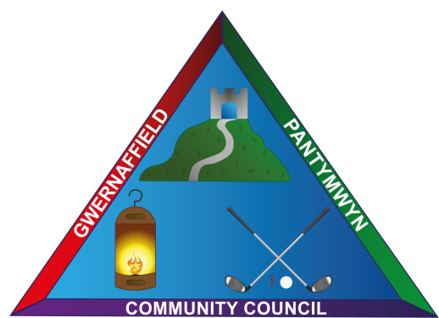
Dear Sir/Madam
You are hereby summoned to a meeting of Gwernaffield and Pantymwyn Community Council at Ysgol Y Waun on Wednesday 10 January 2018 at 7.15pm.
The meeting will consider the agenda items below.
Yours sincerely

Mrs K L Roberts
Clerk to the council

Members of the public and press are welcome to attend.
AGENDA 10 January 2018
- To consider accepting apologies for absence
- To record declarations of interest from members
- To approve the minutes of the last council meeting 6 December 2018
- Matters arising from the last minutes
- Streetscene Matters
- Police Matters
- Councillor Training, future session - information about dementia delivered by Liz Rose, A Dementia Champion. (Cllr. K Johnson)

- Clerk’s update and correspondence

Invite to Mayors St Dwynwen’s Day Charity Dinner Dance and Auction,
2 February 2018, 6.45pm, Clwyd Room, Theatr Clwyd, Raikes Lane, Mold CH7 1YA. Tickets £35.00.

Match Funding Scheme – funding response from Aura to expression of interest for Gwernaffield Playing Fields/Park.

To consider a letter from Flintshire County Council regarding the Town and Community Council Summer Play Scheme Programme 2018.

To consider a letter regarding Flintshire Citizens Advice Bureau Rural Outreach Project.

- To receive, consider and approve the budget for the financial year 2018/2019.

- Planning Matters and Planning Decisions
Planning reference 057760. Mount Pleasant, Cilcain Road, Pantymwyn, Mold, CH7 5DJ. Listed building application for internal alterations and erection of porch over main door.
Planning reference 057710. Cornerways, Cefn Bychan Road, Pantymwyn, Mold CH7 5EL. Erection of replacement dwelling – Decision Approved.
- Review of Community Councillors attendance at monthly meetings.

- To receive items for the 7 February 2018 meeting at Ysgol Y Waun, commencing at 7.15pm.

Agendas and Minutes of meetings can be accessed via the community council website www.gwernaffield.org.uk

