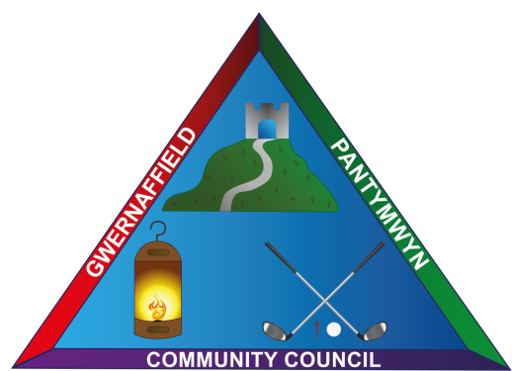
Dear Councillors / Annwyl Gynghorwyr
You are hereby summoned to a meeting of Gwernaffield and Pantymwyn Community Council, 9 November 2022 / 9 Tachwedd at 7.00pm Ysgol Y Waun, Gwernaffield.
The meeting will consider the agenda items below.

Kay Roberts
Clerk / Clerc
Agenda 9 November 2022 / 9 Tachwedd 2022

- (A) Attendance (B) Apologies

- Declaration of interests

- To approve the minutes of the 5 October 2022 meeting.

- (A) To receive any matters arising from the minutes. (B) To approve the minutes.

- To receive any Streetscene Matters.

- To receive an update from the Street Lighting and Road Safety Committee.

- To receive an update from the Community Events Committee.

- To receive any update/s from the Ward County Councillors.

- To consider and approve a Christmas Tree and Festive Lighting for Christmas 2022.

- To approve the schedule of November Accounts for Payment.

10a. To receive quarter 2 Bank reconciliation 1 July – 30 September 2022 and consider half year expenditure to date.

- Clerk’s Update and Correspondence

12.(A) Planning Applications and (B) Decisions

Planning Application Reference: 000592/22 Location: Inchcape, Cefn Bychan Road, Pantymwyn, Mold, CH7 5EN
Proposal: Singe storey infill extension to ground floor dormer and internal alterations.

- The time and date of the next meeting 7 December 2022, 7.00pm at Ysgol Y Waun.

