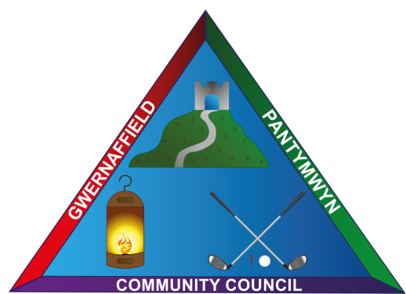

Dear Councillors / Annwyl Gynghorwyr
You are hereby summoned to a meeting of Gwernaffield and Pantymwyn Community Council on 18 May 2022, at 7.00pm at Ysgol Y Waun, Gwernaffield.
The meeting can also be accessed virtually. (Should any resident of the community council area or press wish to gain access to the meeting, please contact the Clerk to advise, at least three days prior to the meeting.) The meeting will consider the agenda items below.

Kay Roberts – Clerk / Clerc
Wednesday 18 May 2022 / Dydd Mercher 18 Mai
Annual Open Public Meeting / Cyfarfod Cyhoeddus Agored Blynyddol
1. Signing of declarations of office (All Councillors)
2. (A) To record attendance (B)To record apologies (Annual and General Meeting)
3. (A) Election of Chairperson for 2022/2023. The Chair to sign their declaration of office.
(B) Election of Vice Chair for 2022/2023. The Vice Chair to sign their declaration of office.
4. Councillors declarations of Interest.
5. To approve the minutes of the last Annual General Meeting on 5 May 2021.
6. To consider co-option of vacant Councillor seats following the uncontested election.
7. To receive the record of Councillor Attendance 2021/2022.
8. To approve the Chair’s allowance and confirm other allowances.
9. To receive nominations to serve on committees and outside bodies.
10. To review and adopt Code of Conduct, Standing Orders and Financial Regulations.
11. To consider the format of future meetings.

GENERAL COMMUNITY COUNCIL MEETING
12. Chairman’s Communications – Welcome Councillors.
13a To consider long standing councillors leaving gifts.
14a To approve the minutes of the 6 April 2022 meeting. 12b Matters Arising.
15. To receive the Clerk’s Update and Correspondence
16. To receive the Annual Return for the year ended 31 March 2022 and the internal auditors report/ JDH Business Supplies 2021/2022.
17. Letter from Rob Roberts MP – message of congratulations to newly elected and
re-elected councillors.
18. To authorise the purchase of seventeen scientific calculators for Ysgol Y Waun Year 6 Leavers.
19. Councillors to advise the clerk of the preferred date of attendance for Code of Conduct Training with Flintshire County Council Monitoring Officer.
20. To consider Streetscene Matters including community council owned Street Lighting.
21. To consider Police Matters – a report of antisocial behaviour in Gwernaffield.
22. To receive a verbal update from the Road Safety committee.
23. To receive a verbal update from the Community Events committee including the recent window dressing competition. 14a. To receive the deadline for the next newsletter.
24. To approve the May Accounts for payment.
25. (A) Planning Applications (B) Planning Decisions
(A) PA: 064369 Adre, Hafod Road, Gwernaffield, CH7 5ET. Application for approval of details reserved by condition three completion of remediation – partial. Attached to Planning Ref: 050568
PA: 064375 Green Hollow, Cilcain Road, Pantymwyn, CH7 5NJ. Widening of vehicular access to the drive.
PA: 064373 Towerside, Tower Lane, Pantymwyn, CH7 5HY. New roof (raised height) to the Lawful development application & replacement Orangery.
PA: 064224 Warren Cottage, Cilcain Road, Pantymwyn, CH7 5NL. Application for approval of details reserved by condition N0 3 (Metal to be used) and 4 Bat avoiding measures, attached to Planning permission reference 060590.
064193 Carraig, Cefn Bychan Road, Pantymwyn, CH7 5EL. RESTROSPECTIVE: Electric sliding gate to be fitted between existing gate posts.
(B) PA: 063885 Cae Rhug Farm, Gwernaffield – Approved.

