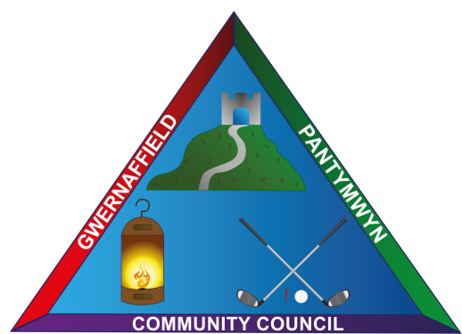
Dear Sir/Madam
You are hereby summoned to a meeting of Gwernaffield and Pantymwyn Community Council at Ysgol Y Waun on Wednesday 7 June 2017 at 7.30pm.
The meeting will consider the agenda items below.
Yours sincerely

Mrs K L Roberts
Clerk to the council

Members of the public and press are welcome to attend.
AGENDA 7 June 2017

- To consider accepting apologies for absence
- To record declarations of interest from members
- To approve the minutes of the last council meeting 10 May 2017
- Matters Arising from the last minutes
- Police Matters – To discuss excessive traffic speed in the villages.
- Clerk’s Update - communication and correspondence
- Friends of Gwernaffield Playing Fields request for consideration of match funding by the community council.
- Exiting Councillors – to consider leaving gift arrangements.
- Woodland Trust – a number of trees will be coming to the villages and requiring planting.
- To consider the Internal Auditors Report and Sign the Annual Return 2016/2017.
- To approve payments to be made.
- Planning Applications (A) Planning Decisions (B)
- To receive items for the next meeting on Wednesday, 5 July 2017 at Ysgol Y Waun.

Agendas and Minutes of meetings can be accessed via the community council website www.gwernaffield.org.uk

